Report on
Water and Wastewater
Rate Study

Report For:

Keyes Community

Services District

5601 7
th
Street
Keyes, CA 95328
(209) 668-8341

Submitted By:
Tuckfield & Associates
Contact: Mr. Clayton Tuckfield
2549 Eastbluff Dr, #450B
Newport Beach, CA 92660
(949) 760-9454
www.tuckfieldassociates.com
November 2021

[This Page Intentionally Left Blank for Two-sided Printing]

Tuckfield & Associates
2549 Eastbluff Drive, Suite 450B, Newport Beach, CA 92660
Phone (949) 760-9454 Fax (949) 760-2725
Email ctuckfield@tuckfieldassociates.com

November 2, 2021

Mr. Ernie Garza
District Manager
Keyes Community Services District
5601 7th Street
Keyes, CA 95328

Dear Mr. Garza:
I am pleased to present this Water and Wastewater Rate Study (Study) report for the Keyes Community Services District (District). This Study reviewed and analyzed the District’s water and wastewater revenue, operation and maintenance expense, and capital needs of the water and wastewater enterprises. Financial plans were developed to determine the need for any rate adjustments.
This study included a review and analysis of the water and wastewater revenue and revenue requirements, number of customers, volumes, and costs of service and evaluation of rate structures. The major objectives of the Study include the following.
- Generate positive levels of income in the Study period
- Maintain operating and capital reserves at or greater than target levels
- Maintain debt service coverage ratios at or greater than the minimum required
- Meet annual capital replacement spending from the water and wastewater rates and charges
- Design rates that are fair and equitable in the current regulatory environment
This report presents the findings and recommendations for the financial plans and rates for the District’s water and wastewater systems. Tables and figures throughout the report are provided to demonstrate the calculations.
It has been a pleasure to work with District staff during the performance of this study. If there are any questions, please contact me at (949) 760-9454.

Very Truly Yours,

TUCKFIELD & ASSOCIATES
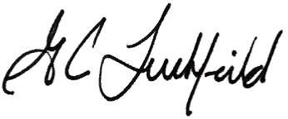
G. Clayton Tuckfield
President/Project Consultant

Table of Contents
Page
Executive Summary ............................................................................................... 1
Enterprise Financial Plans ............................................................................................................................... 1 Proposed Water Rate Structure and Rates..................................................................................................... 1 Water Bill Impacts ........................................................................................................................................... 2 Proposed Wastewater Rate Structure and Rates ........................................................................................... 3
Wastewater Bill Impacts .................................................................................................................................. 3
Introduction ............................................................................................................. 5
Background ..................................................................................................................................................... 5
Objectives ........................................................................................................................................................ 5
Scope of Study ................................................................................................................................................ 6
Assumptions ........................................................................................................... 6
Reserve Policy ................................................................................................................................................ 7
Operating Reserve ................................................................................................................................... 7
Capital Replacement Reserve ................................................................................................................. 7
Emergency Capital Reserve .................................................................................................................... 7
Beginning Balances and Reserve Targets ...................................................................................................... 7
Water Financial Planning ....................................................................................... 8
Current Water Rates ....................................................................................................................................... 8
Water User Classifications .............................................................................................................................. 8 Number of Customers.............................................................................................................................. 8
Number of Water Meters ......................................................................................................................... 9
Water Sales Volumes ............................................................................................................................ 10
Water Financial Plan ..................................................................................................................................... 10 Revenues ............................................................................................................................................... 10 Miscellaneous Revenues ....................................................................................................................... 11
Revenue Requirements ......................................................................................................................... 11 Operation and Maintenance Expense ............................................................................................ 11
Existing Debt Service ..................................................................................................................... 11
Debt Service Reserve Payments ................................................................................................... 12 Water Capital Improvement Program .................................................................................................... 12
Water Financial Plan .............................................................................................................................. 13
Proposed Revenue Adjustments.................................................................................................... 13
Water Rate Design ................................................................................................ 16

Page

Proposed Water Rates .................................................................................................................................. 16
Water Bill Impact Analysis ................................................................................... 17
Water Rate Survey ................................................................................................ 18
Wastewater Financial Planning ........................................................................... 19
Current Wastewater Rates ............................................................................................................................ 19
Wastewater User Classifications ................................................................................................................... 19 Number of Customers............................................................................................................................ 19
Number of Water Meters of Wastewater Customers ............................................................................. 20
Water Sales Volumes of Wastewater Customers ................................................................................. 20
Wastewater Financial Plan ............................................................................................................................ 21 Revenues ............................................................................................................................................... 21
Miscellaneous Revenues ....................................................................................................................... 22
Revenue Requirements ................................................................................................................................ 22 Operation and Maintenance Expense ................................................................................................... 22
Capital Replacement ............................................................................................................................. 23 Wastewater Capital Improvement Program .................................................................................................. 23
Wastewater Financial Plan ............................................................................................................................ 23
Proposed Revenue Adjustments ........................................................................................................... 24
Wastewater Rate Design ...................................................................................... 26
Proposed Wastewater Rates ........................................................................................................................ 26
Wastewater Bill Impact Analysis ......................................................................... 27
Wastewater Rate Survey ...................................................................................... 27
List of Tables
Table ES-1 | Current and Proposed Water Fixed and Variable Charges ........................................................... 1
Table ES-2 | Comparison of Current Single-family Residential Monthly Water Bill with  Bills Using Proposed Water Rates ................................................................................................. 2
Table ES-3 | Current and Proposed Wastewater Fixed Charges ....................................................................... 3
Table ES-4 | Comparison of Current Single-family Residential Monthly Wastewater Bill with  Bills Using Proposed Wastewater Rates ........................................................................................ 3
Table 1 | Assumptions and Planning Factors ................................................................................................ 6
Table 2 | June 30, 2020 Beginning Fund Balances and Reserve Targets ..................................................... 7

 | Page
Table 3 | Current Water Rates ...................................................................................................................... 8
Table 4 | Historical and Projected Average Number of Water Customers .................................................... 9
Table 5 | Historical and Projected Number of Water Meters by Size ............................................................ 9
Table 6 | Historical and Projected Water Consumption (in HCF) ................................................................ 10
Table 7 | Projected Rate-based Water Revenue Using Existing Rates ...................................................... 10
Table 8 | Projected Water Miscellaneous Revenue .................................................................................... 11
Table 9 | Historical and Projected Water Operation and Maintenance Expense ........................................ 12
Table 10 | Water Capital Improvement Program ........................................................................................... 13
Table 11 | Water Financial Plan .................................................................................................................... 14
Table 12 | Current and Proposed Water Fixed and Variable Charges ......................................................... 17
Table 13 | Comparison of Current Single-family Residential Monthly Water Bill with  Bills Using Proposed Water Rates ............................................................................................... 17
Table 14 | Current Wastewater Rates ........................................................................................................... 19
Table 15 | Historical and Projected Average Number of Wastewater Customers by Classification ............. 20
Table 16 | Historical and Projected Number of Water Meters by Size of Wastewater Customers ............... 20
Table 17 | Historical and Projected Water Consumption of Wastewater Customers (in HCF) ..................... 21
Table 18 | Projected Rate-based Wastewater Revenue Using Existing Rates............................................. 22
Table 19 | Projected Wastewater Miscellaneous Revenue ........................................................................... 22
Table 20 | Historical and Projected Wastewater Operation and Maintenance Expense............................... 23
Table 21 | Wastewater Capital Improvement Program with Sources and Uses of Funds ............................ 23
Table 22 | Wastewater Financial Plan ........................................................................................................... 24
Table 23 | Current and Proposed Wastewater Fixed Charges ..................................................................... 27
Table 24 | Comparison of Current Monthly Wastewater Bills with Bills  Using Proposed Wastewater Rates ............................................................................................. 27  List of Figures
Figure 1 | Water Financial Plan Comparison of Annual Revenue with Revenue Requirements ................. 15
Figure 2 | Water Cash Reserves Comparison of Projected End of Year Cash Reserves with
 | Target Reserve Levels ................................................................................................................. 16
Figure 3 | Wastewater Financial Plan Comparison of Annual Revenue with Revenue Requirements ........ 25
Figure 4 | Wastewater Cash Reserves Comparison of Projected End of Year Cash Reserves with
 | Target Reserve Levels ................................................................................................................. 26
Page

List of Charts
Chart ES-1 Comparison of Single-family Residential Monthly Water Bills Using 14 HCF ................................ 2 Chart ES-2 Comparison of Single-family Residential Monthly Wastewater Bills .............................................. 4 Chart 1 Comparison of Single-family Residential Monthly Water Bills Using 14 HCF .............................. 18 Chart 2 Comparison of Single-family Residential Monthly Wastewater Bills ............................................ 28

Executive Summary
The Keyes Community Services District (District) retained Tuckfield & Associates to conduct a comprehensive Water and Wastewater Rate Study (Study). The major objective of the Study is to determine the water and wastewater rates for FY 2021-22 to FY 2025-26 (the “Study Period”) by projecting revenues and revenue requirements for each system and by analyses to determine the costs of providing service.

Enterprise Financial Plans
Forward-looking financial plans were developed for the water and wastewater enterprises that projected revenue requirements (costs) of each system. The amount of revenue generated from the current rates for each system was determined for FY 2021-22 through FY 2025-26 and was found to be sufficient to maintain financially sustainable water and wastewater enterprises for the Study period. No revenue increases are necessary to maintain the financial health of each system. Table 11 and 22 provide the financial plans for the water and wastewater systems respectively.

Proposed Water Rate Structure and Rates
No revenue increases are recommended for the water enterprise and the current uniform rate structure is recommended to be maintained for the District. The proposed water rate structure and rates are the same as the current rates and are provided in Table ES-1.
Table ES-1
Current and Proposed Water Fixed and Variable Charges
Current | January 1, January 1, January 1, January 1, January 1,
Rate | 2022 2023 2024 2025 2026
Fixed Charge ($ per month)

$34.97  $27.97 | $34.97 | $34.97 | $34.97 | $34.97 | $34.97
 | $27.97 | $27.97 | $27.97 | $27.97 | $27.97
Residential
Multifamily
Commercial
5/8" | $34.97 | $34.97 | $34.97 | $34.97 | $34.97 | $34.97
3/4" | $34.97 | $34.97 | $34.97 | $34.97 | $34.97 | $34.97
1" | $58.27 | $58.27 | $58.27 | $58.27 | $58.27 | $58.27
1.5" | $116.55 | $116.55 | $116.55 | $116.55 | $116.55 | $116.55
2" | $186.49 | $186.49 | $186.49 | $186.49 | $186.49 | $186.49
3" | $349.64 | $349.64 | $349.64 | $349.64 | $349.64 | $349.64
4" | $582.74 | $582.74 | $582.74 | $582.74 | $582.74 | $582.74
6" | $1,398.58 | $1,398.58 | $1,398.58 | $1,398.58 | $1,398.58 | $1,398.58
Variable Charge ($ per HCF)

$1.73
All Consumption$1.73 $1.73 $1.73 $1.73 $1.73

Water Bill Impacts
There are no impacts to customer water bills because the proposed water rates are the same as the current water rates. Table ES-2 shows that there are no impacts to Single-family Residential (SFR) water bills from the water rates presented in Table ES-1.
Table ES-2
Comparison of Current Single-family Residential Monthly Water Bill with Bills Using Proposed Water Rates
 |  |  | Current Bill |  |  | Proposed January 1, 2022 Bill
 |  | Service | Volume | Current | Service | Volume Proposed | Dollar | Percent
Description | Use (HCF) | Charge | Charge | Bill | Charge | Charge Bill | Difference | Change
 | 0 | $34.97 | $0.00 | $34.97 | $34.97 | $0.00 $34.97 $0.00 |  | 0.0%
Very Low | 5 | $34.97 | $8.65 | $43.62 | $34.97 | $8.65 $43.62 $0.00 |  | 0.0%
Low | 8 | $34.97 | $13.84 | $48.81 | $34.97 | $13.84 $48.81 $0.00 |  | 0.0%
Median | 10 | $34.97 | $17.30 | $52.27 | $34.97 | $17.30 $52.27 $0.00 |  | 0.0%
Average | 14 | $34.97 | $24.22 | $59.19 | $34.97 | $24.22 $59.19 $0.00 |  | 0.0%
High | 20 | $34.97 | $34.60 | $69.57 | $34.97 | $34.60 $69.57 $0.00 |  | 0.0%
Very High | 30 | $34.97 | $51.90 | $86.87 | $34.97 | $51.90 $86.87 $0.00 |  | 0.0%
 | 50 | $34.97 | $86.50 | $121.47 | $34.97 | $86.50 $121.47 $0.00 |  | 0.0%

Chart ES-1 has been prepared to compare the District’s average SFR water bill with those of other local communities. The chart is prepared using the smallest meter size listed in a community’s rate schedule and at a consumption of 14 HCF. The chart indicates that a District SFR customer will experience a bill that is in the midrange of the communities listed.
Chart ES-1
Comparison of Single-family Residential Monthly Water Bills Using 14 HCF
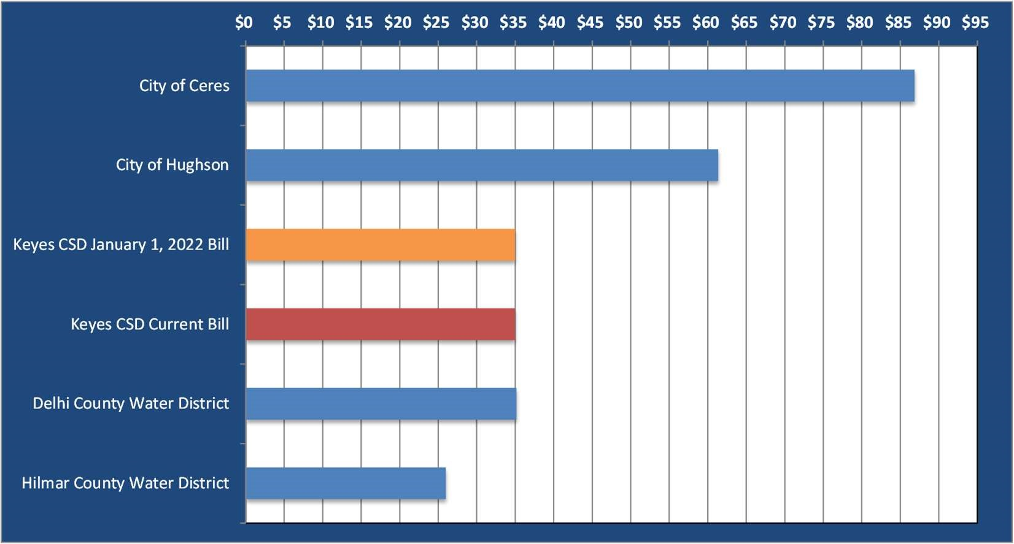
Note: Above table uses water rates in effect October 2021. Keyes CSD bill is based on the rate structure and rates in Table ES-1. Communities other than KCSD are based on the smallest meter size listed in their rate schedule.

Proposed Wastewater Rate Structure and Rates
No revenue increases are recommended for the wastewater enterprise and the current wastewater rate structure is recommended to be maintained by the District. Table ES-3 presents the current and proposed wastewater rates for the next five years.
Table ES-3
Current and Proposed Wastewater Fixed Charges
Current | January 1, January 1, January 1, January 1, January 1,
Rate | 2022 2023 2024 2025 2026
Fixed Charge ($ per month)

Single-family | $64.23 | $64.23 | $64.23 | $64.23 | $64.23 | $64.23
Multifamily | $51.39 | $51.39 | $51.39 | $51.39 | $51.39 | $51.39
Commercial Low | $64.23 | $64.23 | $64.23 | $64.23 | $64.23 | $64.23
Commercial Medium | $111.28 | $111.28 | $111.28 | $111.28 | $111.28 | $111.28
Commercial High | $166.67 | $166.67 | $166.67 | $166.67 | $166.67 | $166.67
Schools (Elem and Middle) | $1,816.67 | $1,816.67 | $1,816.67 | $1,816.67 | $1,816.67 | $1,816.67

Wastewater Bill Impacts
There are no impacts to the customer wastewater bills because the proposed wastewater rates are the same the current rates. Table ES-4 shows that there are no impacts to SFR wastewater bills from the proposed wastewater rates from Table ES-3.
Table ES-4
Comparison of Current Monthly Wastewater Bills with Bills Using
Proposed Wastewater Rates
 |  | Proposed January 1, 2022 Bill
Customer Class |  | Current Monthly Bill |  | Proposed Monthly Bill |  | Dollar Difference |  | Percent  Increase
 | Single-family |  | $64.23 |  | $64.23 |  | $0.00 |  | 0.0%
 | Multifamily |  | $51.39 |  | $51.39 |  | $0.00 |  | 0.0%
 | Commercial Low |  | $64.23 |  | $64.23 |  | $0.00 |  | 0.0%
 | Commercial Medium |  | $111.28 |  | $111.28 |  | $0.00 |  | 0.0%
 | Commercial High |  | $166.67 |  | $166.67 |  | $0.00 |  | 0.0%
 | Schools (Elem and Middle) |  | $1,816.67 |  | $1,816.67 |  | $0.00 |  | 0.0%

Chart ES-2 has been prepared to compare the District’s average SFR wastewater bill per month bill with those of other communities. The chart indicates that the District’s SFR wastewater bill is in the mid to upper range of the communities listed.
Chart ES-2
Comparison of Single-family Residential Monthly Wastewater Bills
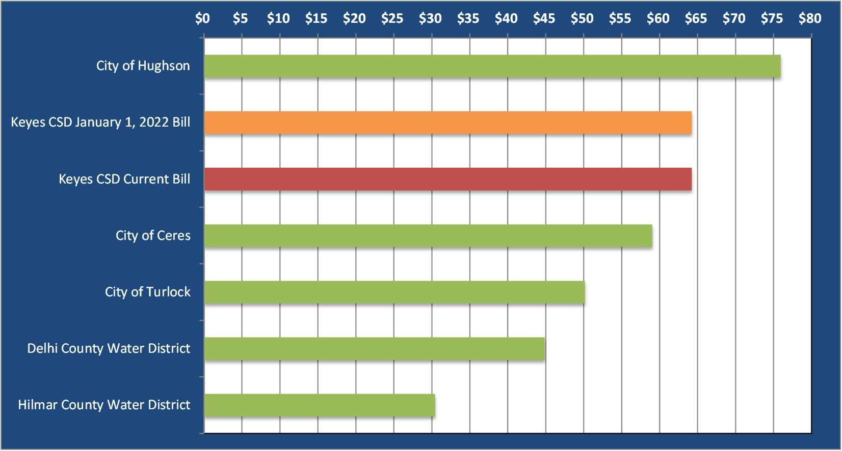
Note: Above table uses wastewater rates in effect October 2021. Keyes Community Services District bill is based on the rate structure and rates in Table ES-3.

Introduction
The Keyes Community Services District (District) retained Tuckfield & Associates to conduct a comprehensive Water and Wastewater Rate Study (Study) for its water and wastewater enterprise systems. This Study develops pro forma statements of revenues and revenue requirements for each enterprise and determines any revenue adjustments required to provide financially sustainable water and wastewater enterprises.

Background
The Keyes Community Services District (District) provides water and wastewater service to about 1,375 customers in the central-south region of Stanislaus County, approximately 9 miles southeast of the City of Modesto along Highway 99. The customer base consists mostly of residential customers with a small number of commercial customers, and an elementary and middle school.
The District’s water is produced from wells located within the District and distributed through a pipeline network of various sizes. Wastewater is collected through the District’s collection system and is conveyed to the treatment facility owned by the City of Turlock (Turlock). The District has an agreement with Turlock that secures its rights to 50 percent of the capacity of the trunk conveyance pipeline in return for reimbursement for the District’s share of the construction cost. The District has also contracted for 0.597 mgd of capacity of the treatment plant owned by Turlock for treatment of the District’s wastewater
On November 6, 2006, the District was issued a Notice of Non-Compliance from the California Department of Public Health (CDPH). In 2018, the District completed construction of an Arsenic Treatment Facility that brought the District into compliance with CDPH.
In November of 2020, the District entered into a settlement agreement with certain defendants whereby the defendants will pay the District certain sums of money to settle allegations associated with Trichloropropane (TCP) contamination of District wells. The money received from the settlement will be used by the District towards water system capital improvement plan (CIP) projects associated with District wells and other water CIP projects necessary to address the District’s aging facilities.

Objectives
The objectives of this Study are to (1) review the current and future financial status of each of the water and wastewater enterprises, (2) make any adjustments to the revenue being received to ensure that the financial obligations are being met now and in the future, including adequate reserves and debt service coverage, and (3) design water and wastewater rates that generate the required revenue while being fair and equitable for its customers.

Scope of the Study
This Study includes the findings and recommendations of analyzing each of the water and wastewater system’s financial status and related CIP projects. Historical trends were analyzed from data supplied by the District showing the number of customers, volumes, revenue, and revenue requirements.
Revenue requirements of each enterprise includes operation and maintenance (O&M) expense, routine capital outlays, CIP funding, debt service, and additions to reserves. Changing conditions such as additional facilities, system growth, employee additions/reductions, and non-recurring maintenance expenditures are recognized. Inflation for ongoing expenditures is included to reflect cost escalation.
The financial plan and rates developed herein are based on funding of the CIP and estimates of O&M expenses provided by the District. Deviation from the financial plans, construction cost estimates and funding requirements, major operational changes, or other financial policy changes that were not foreseen, may result in the need for lower or higher revenue than anticipated. It is suggested that the District conduct an update to the rate study at least every three years for prudent rate planning.

Assumptions
Several assumptions were used to conduct the Study for the period FY 2021-22 to FY 2025-26. The assumptions included growth rates in customer accounts and related consumption, expense inflation factors, financing and other assumptions used for projecting revenue and expense and estimating debt service payments. The financial planning assumptions are provided in Table 1.
Table 1
Assumptions and Planning Factors
Description | Value
Annual Account & Demand growth [1]
Residential | 0.5%
All Other | 0.0%
Interest earnings on fund reserves (annual) | 0.25%
Cost Escalation
Personnel Services [2] | 2.0%
Benefits | 8.0%
Electrical Power | 3.0%
Chemicals | 3.0%
Purchased Water | 4.0%
All Other Operations & Maintenance | 2.0%
Capital | 3.0%

- Annualized growth in water accounts is based on historicalinformation provided by staff.
- Personnel Services growth in staffing, promotions, and inflation
is 2.0% annually.

Reserve Policy
The District has reserve policy goals that include maintaining the level of reserves for the water and wastewater systems at appropriate levels. The reserve goals provide a means to meet unanticipated reductions in revenues, meet changes in the costs of providing services, provide for fixed asset repair and replacement, natural disaster needs, and other issues. The reserves also provide guidelines to maintain the financial health and stability of the enterprise funds. The reserve types and the amount of reserves used in this Study are discussed below.

Operating Reserve
The purpose of the Operating Reserve is to provide working capital to meet cash flow needs during normal operations and support the operation, maintenance, and administration of the utility. This reserve ensures that operations can continue should there be significant events that impact cash flows. The target balance to be maintained is 180 days (50 percent) of the current annual operating expense budget.

Capital Replacement Reserve
The purpose of the Capital Replacement Reserve is to fund future replacement of assets and CIP projects. The capital reserves are used to fund replacement of system assets as they reach their useful life or reach obsolescence. The reserve target has been established as 50 percent of annual depreciation.

Emergency Capital Reserve
The purpose of the Emergency Capital Reserve is to provide protection against catastrophic loss and to provide a cushion for inaccuracy in the long-range replacement program. The Target reserve is established at 3 percent of the value of current capital fixed asset value. The system values are currently estimated at about $23.7 million for the water system and about $2.2 million for the wastewater system. These values will increase as CIP is booked into fixed assets.

Beginning Balances and Reserve Targets
As of June 30, 2021, the District’s beginning reserve balances are listed in the table below. The reserves are used in developing the financial plans for the water and wastewater utility systems. The Target Reserves are also provided in the table.
Table 2
June 30, 2021 Beginning Fund Balances and Reserve Targets
 | Water |  | Wastewater
 | Reserve | Reserve | Reserve | Reserve
Reserve Type | Balance | Target | Balance | Target
Operating Fund Reserve | $4,427,747 | $358,000 | $3,233,695 | $497,000
Capital Replacement Reserve | $533,408 | $414,000 | $428,734 | $65,000
Emergency Capital Reserve | $0 | $713,000 | $0 | $68,000
Total | $4,961,155 | $1,485,000 | $3,662,429 | $630,000

Water Financial Planning
Financial planning for the water system includes identifying and projecting revenues and revenue requirements for a five-year planning period. This section discusses current water rates, current user classifications, projected revenues and revenue requirements, capital improvement expenditures and financing sources, and proposed revenue adjustments.

Current Water Rates
Table 3 provides the current water rates of the water system. The water rates consist of monthly fixed and variable charges to residential and non-residential customers. Residential customers are charged the same fixed charge monthly while Commercial customers are charged a monthly fixed charge that increases with their meter size.
All customers are charged for consumption using a uniform volume charge whereby all customers are charged the same rate for water consumption.
Table 3
Current Water Rates
 | Fixed
Description | Charges
 | $/month
Residential | $34.97
Multifamily | $27.97
Commercial  5/8" | $34.97
3/4" | $34.97
1" | $58.27
1.5" | $116.55
2" | $186.49
3" | $349.64
4" | $582.74
6" | $1,398.58
 | Variable
Customer Class | Rate
($/HCF)
All Customers $1.73

Water User Classifications

Number of Customers
The District classifies water customers as Single-family Residential (SFR), Multifamily Residential (MFR, consisting of apartments and mobile homes), and Commercial. Residential customers account for over 96 percent of the total customers/accounts served by the water system. Customer growth is projected to occur in SFR accounts at 0.5 percent annually, or about 6 new accounts per year. Table 4 provides the historical and projected average number of water customers by classification.

Table 4 Historical and Projected Average Number of Water Customers
 | Historical |  |  | Projected
Customer Class | FY 20-21 | FY 21-22 | FY 22-23 | FY 23-24 | FY 24-25 | FY 25-26
Number of Accounts  Single-family [1] | 1,272 | 1,278 | 1,284 | 1,290 | 1,296 | 1,302
Multifamily [1] | 29 | 29 | 29 | 29 | 29 | 29
Commercial  Total Accounts | 44 | 44 | 44 | 44 | 44 | 44
 | 1,345 | 1,351 | 1,357 | 1,363 | 1,369 | 1,375
Number of Dwelling Units  Single-family [1] | 1,272 | 1,278 | 1,284 | 1,290 | 1,296 | 1,302
Multifamily [1] | 448 | 450 | 452 | 454 | 456 | 458

[1] Residential accounts/units increase at 0.5% annually.

Number of Water Meters
Table 5 provides a summary of the current and projected average number of water customers by meter size. Most customers have a 3/4-inch meter (96 percent) installed at the service location. It is assumed that all new residential customers will have 1-inch meters installed and this is the minimum size for new meter installations for the District’s customer base.
Table 5
Historical and Projected Average Number of Water Meters by Size
Historical  Description FY 20-21 |  |  |  | Projected
 |  | FY 21-22 | FY 22-23 | FY 23-24 | FY 24-25 | FY 25-26
Active Water Meters/Accounts [1]  5/8" 29 |  | 450 | 29 | 29 | 29 | 29
3/4" | 1,294 | 1,294 | 1,294 | 1,294 | 1,294 | 1,294
1" | 3 | 9 | 15 | 21 | 27 | 33
1.5" | 1 | 1 | 1 | 1 | 1 | 1
2" | 11 | 11 | 11 | 11 | 11 | 11
3" | 3 | 3 | 3 | 3 | 3 | 3
4"  Total Meters | 4 | 4 | 4 | 4 | 4 | 4
 | 1,345 | 1,772 | 1,357 | 1,363 | 1,369 | 1,375

[1] Historical water accounts/meters for FY 20-21 were provided through City billing records.

Water Sales Volumes
Table 6 provides the historical and projected water sales volume by customer classification. Water sales volumes were projected by recognizing the growth in the number of accounts and the FY 2018-19 water use per customer.

Table 6 Historical and Projected Water Consumption (in HCF)
Description | Historical |  |  | [1]  Projected
 | FY 20-21 | FY 21-22 | FY 22-23 | FY 23-24 | FY 24-25 | FY 25-26
Single-family | 310,656 | 222,125 | 223,168 | 224,211 | 225,254 | 226,297
Multifamily | 13,132 | 45,590 | 45,792 | 45,995 | 46,197 | 46,400
Commercial  Total Projected Consumption | 50,066 | 58,838 | 58,838 | 58,838 | 58,838 | 58,838
 | 373,854 | 326,553 | 327,798 | 329,044 | 330,289 | 331,535

[1] Forecast assumes that the use per customer from FY 18-19 and applied to the number of customers.

Water Financial Plan
The financial plan provides the means of analyzing the revenue and revenue requirements of the water system and its impact on reserves as well as the ability to fund on-going operation and maintenance (O&M) expense and capital infrastructure requirements. Below is a discussion of the projection of revenue, O&M expense, capital improvement needs of the water system and its financing, debt service requirements, and revenue adjustments needed to maintain a sustainable water enterprise.

Revenues
The Water Fund receives revenue from rates and charges for water service and miscellaneous sources. Revenue from water rates is projected by applying the current water rates to the projected number of accounts and consumption volume. Table 7 presents the projected revenue from current water rates of the water system.

Table 7 Projected Rate-based Water Revenue Using Existing Rates
Description |  |  | Projected
 | FY 21-22 | FY 22-23 | FY 23-24 | FY 24-25 | FY 25-26
Water Service Revenues  Fixed Charges ^{[1]} | $765,242 | $768,430 | $771,620 | $774,809 | $777,998
Variable Charges ^{[2]} | 564,939 | 567,093 | 569,248 | 571,401 | 573,557
Total Revenues From Current Rates | $1,330,181 | $1,335,523 | $1,340,868 | $1,346,210 | $1,351,555
- FY 21-22 and forecast revenue calculated by multiplying current water service rate by the number of projected meters.
- FY 21-22 and forecast revenue calculated by multiplying projected water sales by the current variable rates.

Miscellaneous Revenue
Miscellaneous revenues are received from several sources including inspection fees, late charges, penalties, backflow fees, and other sources. Table 8 below provides sources of miscellaneous revenue.

Table 8 Projected Water Miscellaneous Revenue
Description | Budget |  | Projected
 | FY 21-22 | FY 22-23 | FY 23-24 | FY 24-25 | FY 25-26
Inspection Fee | $500 | $500 | $500 | $500 | $500
Late Charges | 45,000 | 45,211 | 45,422 | 45,633 | 45,844
Returned Check | 300 | 301 | 302 | 303 | 304
Water Violation | 500 | 502 | 504 | 506 | 508
Taxes Current Secured | 600 | 600 | 600 | 600 | 600
Taxes Current Unsecured | 100 | 100 | 100 | 100 | 100
Other Revenue | 4,000 | 4,000 | 4,000 | 4,000 | 4,000
Credit Card Fee | 4,500 | 4,521 | 4,542 | 4,563 | 4,584
Backflow Test | 750 | 750 | 750 | 750 | 750
Total Miscellaneous Revenues $56,250 $56,485 $56,720 $56,955 $57,190

Revenue Requirements
Revenue requirements of the water system include O&M expense, debt service, payments to debt reserves, and capital replacement. Each of these items are discussed below.

Operation and Maintenance Expense
O&M expenses are an on-going obligation of the water system and such costs are normally met from water service revenue. O&M includes the cost to operate and maintain the water supply, reservoirs, and distribution system facilities. Costs also include technical services and other general and administrative expenses.
O&M has been projected recognizing the major expense categories of personnel services, electric power expense, chemicals, all other expenses, and capital outlay. Personnel costs consist of salaries and benefits expense of those personnel directly involved with providing water service. Salaries and wages are projected to increase by 2 percent annually, while benefits expense is projected to increase by 8 percent annually. Electric power expense is projected to increase annually by 3 percent while chemicals expense increases also by 3 percent annually. All other O&M expense is projected to increase by 2 percent annually. Capital outlay is projected to increase by 3 percent annually. Table 9 provides a summary of the O&M expenses for the Study period.

Existing Debt Service
The water system has outstanding debt from a State Water Resources Control Board (SWRCB) Safe Drinking Water (SDW) State Revolving Fund (SRF) loan. The annual payments are about $10,000 annually.

Table 9
Historical and Projected Water Operation and Maintenance Expense
Description | Historical | Budget |  | Projected
 | FY 20-21 | FY 21-22 | FY 22-23 | FY 23-24 | FY 24-25 | FY 25-26
Admintration  Admin Salaries | $77,000 | $82,200 | $83,844 | $85,521 | $87,232 | $88,976
Admin Benefits | 69,550 | 78,700 | 84,996 | 91,796 | 99,140 | 107,070
All Other  Subtotal | 130,179 | 98,450 | 99,909 | 101,905 | 103,944 | 106,021
 | $276,729 | $259,350 | $268,749 | $279,222 | $290,316 | $302,067
Maintenance  Maint Salaries | $116,069 | $123,000 | $125,460 | $127,969 | $130,528 | $133,139
Maint Benefits | 105,715 | 114,000 | 116,280 | 118,606 | 120,979 | 123,399
Maintenance Utilities | 92,000 | 95,000 | 98,223 | 101,170 | 104,205 | 107,331
Maintenance Chlorine | 4,400 | 5,000 | 5,170 | 5,345 | 5,526 | 5,713
All Other  Subtotal | 194,602 | 119,450 | 121,839 | 124,276 | 126,762 | 129,295
 | $512,786 | $456,450 | $466,972 | $477,366 | $488,000 | $498,877
Arsenic Treatment Facility  Treatment Chemicals | $35,000 | $50,000 | $51,696 | $53,450 | $55,261 | $57,134
Sludge Disposal | 25,000 | 30,000 | 30,600 | 31,212 | 31,836 | 32,473
Equipment Maintenance | 17,000 | 20,000 | 20,400 | 20,808 | 21,224 | 21,648
Arsenic Treatment Facility $77,000 $100,000 $102,696 $105,470 $108,321 $111,255

Total Water System O&M Expense $866,515 $830,800 $853,867 $877,972 $903,028 $929,082

Debt Service Reserve Payments
A reserve is required for the SWRCB SDW SRF loan discussed above. The debt service reserve may be funded over a 10-year period and results in an annual payment of about 10 percent of the annual loan payment over that time frame.

Capital Replacement
An annual amount for capital replacement is generated from the current water rates and financial plan and is used towards capital spending or kept in reserve for such spending. The amount ranges from about $480,000 to $560,000 annually in the Study period.

Water Capital Improvement Program
The District has developed a CIP shown in Table 10 that lists capital expenditures for FY 2021-22 through FY 202526. Over this period the District projects that it will spend a total of about $4.6 million related to wells, storage, and other projects. The CIP is planned to be funded from lawsuit proceeds, District rate revenue, and District cash reserves.
In November of 2020, the District entered into a settlement agreement with certain defendants whereby the defendants will pay the District certain sums of money, totaling $9 million, to settle allegations associated with Trichloropropane (TCP) contamination of District wells. The money received from the settlement will be used to pay for CIP projects associated with District wells identified in Table 10. The lawsuit proceeds are shown in Table 11 under Water Capital Sources of Funds.
Table 10
Water Capital Improvement Program
Description | Budget |  | Projected
 | FY 21-22 | FY 22-23 | FY 23-24 | FY 24-25 | FY 25-26
Current Capital Improvement Program (CIP) Projects [1]  Maintenance Shop and Property Purchase | $450,000 | $0 | $0 | $0 | $0
Well 7 - 123 TCP | 1,203,000 | - | - | - | -
Well 10 - 123 TCP | 2,119,000 | - | - | - | -
Washington Nunes Tie-in | - | - | 31,800 | - | -
2nd Storage Tank | - | - | 636,500 | - | -
Proposed Asset Replacement Projects [2] | - | - | - | - | 200,000
Total Water CIP
$3,772,000
$0
$668,300
$0
$200,000
[1] CIP Source: FY 21-22 City CIP document.

Water Financial Plan
A financial plan has been prepared that includes the projected revenues and revenue requirements that were identified for the water system. The financial plan, presented in Table 11, incorporates specific financial planning goals to provide guidance to maintain the health of the water utility on an on-going basis. The goals included the following.

- Generate positive levels of income in each year of the Study period
- Fund the capital improvement program requirements
- Maintain the operating and capital reserves at or greater than target levels
- Fund the required debt service reserves
- Maintain debt service coverage ratios at or greater than the minimum required

Proposed Revenue Adjustments
Table 11 provides the annual revenue increases recommended to meet the financial planning criteria for the five-year Study Period. The financial plan indicates that no revenue increases are required during the Study Period.

Table 11
Water Financial Plan
Description |  |  | Projected
 | FY 21-22 | FY 22-23 | FY 23-24 |  |  | FY 24-25 |  | FY 25-26
Proposed Revenue Increase (January 1) | 0.0% | 0.0% | 0.0% |  |  | 0.0% |  | 0.0%
Water Operations
Revenue  Revenues from Existing Water Rates [1] | $1,330,181 | $1,335,523 | $1,340,868 |  |  | $1,346,210 |  | $1,351,555
Additional Revenue from Revenue Increases [2] | - | - | - |  |  | - |  | -
Miscellaneous Income [3] | 56,250 | 56,485 | 56,720 |  |  | 56,955 |  | 57,190
Interest Income [4] | 15,887 | 21,305 | 24,319 |  |  | 27,292 |  | 29,558
Total Revenues | $1,402,318 | $1,413,313 |  | $1,421,907 |  | $1,430,457 |  | $1,438,303
Revenue Requirements  Operation and Maintenance Expense | $715,800 | $735,721 |  | $756,588 |  | $778,316 |  | $800,944
Capital Outlay | 15,000 | 15,450 |  | 15,914 |  | 16,391 |  | 16,883
Arsenic Treatment Facility | 100,000 | 102,696 |  | 105,470 |  | 108,321 |  | 111,255
SWRCB SDW SRF Loan | 10,956 | 10,956 |  | 10,956 |  | 10,956 |  | 10,956
Payment to Debt Service Reserve [5] | 1,200 | 1,200 |  | 1,200 |  | 1,200 |  | 1,200
Transfer to Water Capital Spending | 559,362 | 537,290 |  | 521,779 |  | 504,273 |  | 486,065
Total Revenue Requirements  Net Funds Available Before Capital | $1,402,318 | $1,403,313 |  | $1,411,907 | $1,419,457 |  | $1,427,303
 | $0 | $10,000 |  | $10,000 | $11,000 |  | $11,000
Water Capital
Capital Sources of Funds
Lawsuit Proceeds | $6,000,000 | $1,000,000 |  | $1,000,000 | $1,000,000 |  | $0
Transfer from Water Operations  Total Capital Sources  Capital Uses of Funds | 559,362 | 537,290 |  | 521,779 | 504,273 |  | 486,065
 | $6,559,362 | $1,537,290 |  | $1,521,779 | $1,504,273 |  | $486,065
Capital Improvement Program | $3,772,000 | $0 |  | $668,300 | $0 |  | $200,000
Total Capital Improvement Spending | $3,772,000 | $0 |  | $668,300 | $0 |  | $200,000
Net Capital Sources and Uses | $2,787,362 | $1,537,290 |  | $853,479 | $1,504,273 |  | $286,065
Net Funds Available After Capital | $2,787,362 | $1,547,290 |  | $863,479 | $1,515,273 |  | $297,065
Available Operating and Capital Reserves
Beginning available reserves [6] | $4,961,155 | $7,748,517 |  | $9,295,806 | $10,159,285 |  | $11,674,558
Additions (reductions) | 2,787,362 | 1,547,290 |  | 863,479 | 1,515,273 |  | 297,065
Ending available reserves | 7,748,517 | 9,295,806 |  | 10,159,285 | 11,674,558 |  | 11,971,623
Target Reserves [7] | 1,485,000 | 1,579,000 |  | 1,609,000 | 1,643,000 |  | 1,673,000
Above (below) Target | $6,263,517 | $7,716,806 |  | $8,550,285 | $10,031,558 |  | $10,298,623
Debt Service Coverage
Net Revenues [8] | $6,571,518 | $1,559,446 |  | $1,543,935 | $1,527,429 |  | $509,221
Annual Debt Service | 10,956 | 10,956 |  | 10,956 | 10,956 |  | 10,956
Coverage [9] | 59980% | 14233% |  | 14092% | 13941% |  | 4648%

- Projected using the existing rate schedule effective July 1,2019.
- Additional revenue from proposed rate adjustments.
- Includes late charges, miscellaneous, and other income.
- Interest earnings on the average fund balance calculated at 0.25%.
- Payment to fund required reserves for the SWRCB SDW SRF Loan.
- The available beginning FY 21-22 cash balance provided by City.
- Includes Operation and Maintenance reserve, Capital Replacement reserve, and Emergency Capital reserve.
- Includes all revenues of the water system.
- Minimum coverage is 125 percent.
A graphical depiction of the revenue and revenue requirements from Table 11 are presented in Figure 1. Revenue using the current rates is shown as the red line. Figure 1 shows that the revenue from current water rates meets annual O&M expense and capital spending needs during the Study period and 10-year period. The current water rates generate sufficient revenue to initially provide about $500,000 annually for capital spending needs or for accumulation in capital reserves shown as the green column in Figure 1. The annual amount decreases over the 10-year period.
Figure 1
Water Financial Plan
Comparison of Annual Revenue with Revenue Requirements

$0.0
$0.2
$0.4
$0.6
$0.8
$1.0
$1.2
$1.4
$1.6
FY 21-22
FY 25-26
FY 27-28
FY 29-30
FY 23-24
Revenue and Revenue Requirements ($ Millions)
O&M
Arsenic Treatment Facility
Replacement
Debt Service
Transfer to Water Capital Spending
Additions to Reserves
Revenue with Increases
Revenue w/o Increases

Figure 2 shows the projected cash reserves and the target reserves established for the District. The columns represent the cash position at the end of the year (which includes operating and capital reserves) while the red line represents the Target Reserve level for the District. The figure shows that the District maintains the cash reserves to at least the Target reserve maintenance level and has adequate cash reserves during all years of the 10-year period.
Figure 2
Water Cash Reserves
Comparison of Projected End of Year Cash Reserves with Target Reserve Level

$0
$2
$4
$6
$8
$10
$12
$14
FY 21-22
FY 23-24
FY 25-26
FY 27-28
FY 29-30
(
)
$ Millions
Total Reserves
Target Reserves

Water Rate Design
From the analysis in Table 11, no revenue increases are required to maintain a financially sustainable water enterprise. Additionally, no change is proposed in the District’s current water rate structure. The current water rate structure charges for all water consumed through the meter for each District water customer.

Proposed Water Rates
Table 12 presents the proposed fixed charges and variable charges for the water system for the next five years. Table 12 also includes the current fixed and variable rates as well as the proposed water rates using the current uniform volume rate structure.
Table 12
Current and Proposed Water Fixed and Variable Charges
Current | January 1, January 1, January 1, January 1, January 1,
Rate | 2022 2023 2024 2025 2026
Fixed Charge ($ per month)

$34.97  $27.97 | $34.97 | $34.97 | $34.97 | $34.97 | $34.97
 | $27.97 | $27.97 | $27.97 | $27.97 | $27.97
Residential
Multifamily
Commercial
5/8" | $34.97 | $34.97 | $34.97 | $34.97 | $34.97 | $34.97
3/4" | $34.97 | $34.97 | $34.97 | $34.97 | $34.97 | $34.97
1" | $58.27 | $58.27 | $58.27 | $58.27 | $58.27 | $58.27
1.5" | $116.55 | $116.55 | $116.55 | $116.55 | $116.55 | $116.55
2" | $186.49 | $186.49 | $186.49 | $186.49 | $186.49 | $186.49
3" | $349.64 | $349.64 | $349.64 | $349.64 | $349.64 | $349.64
4" | $582.74 | $582.74 | $582.74 | $582.74 | $582.74 | $582.74
6" | $1,398.58 | $1,398.58 | $1,398.58 | $1,398.58 | $1,398.58 | $1,398.58
Variable Charge ($ per HCF)

$1.73
All Consumption$1.73 $1.73 $1.73 $1.73 $1.73

Water Bill Impact Analysis
There is no impact to SFR customer water bills because the analysis in Table 11 determined that no revenue increases are required and the there is no change to the current District rate structure. As shown in Table 13, a SFR customer using the average consumption of 14 HCF monthly experiences no change in their monthly bill.
Table 13
Comparison of Current Single-family Residential Monthly Water Bill with Bills Using Proposed Water Rates
 |  |  | Current Bill |  |  | Proposed January 1, 2022 Bill
 |  | Service | Volume | Current | Service | Volume Proposed | Dollar | Percent
Description | Use (HCF) | Charge | Charge | Bill | Charge | Charge Bill | Difference | Change
 | 0 | $34.97 | $0.00 | $34.97 | $34.97 | $0.00 $34.97 $0.00 |  | 0.0%
Very Low | 5 | $34.97 | $8.65 | $43.62 | $34.97 | $8.65 $43.62 $0.00 |  | 0.0%
Low | 8 | $34.97 | $13.84 | $48.81 | $34.97 | $13.84 $48.81 $0.00 |  | 0.0%
Median | 10 | $34.97 | $17.30 | $52.27 | $34.97 | $17.30 $52.27 $0.00 |  | 0.0%
Average | 14 | $34.97 | $24.22 | $59.19 | $34.97 | $24.22 $59.19 $0.00 |  | 0.0%
High | 20 | $34.97 | $34.60 | $69.57 | $34.97 | $34.60 $69.57 $0.00 |  | 0.0%
Very High | 30 | $34.97 | $51.90 | $86.87 | $34.97 | $51.90 $86.87 $0.00 |  | 0.0%
 | 50 | $34.97 | $86.50 | $121.47 | $34.97 | $86.50 $121.47 $0.00 |  | 0.0%

Water Rate Survey
A water rate survey was conducted for neighboring communities to the Keyes Community Services District shown in Chart 1. The rate survey includes rate schedules in effect October 2021. The chart is prepared using the smallest meter size listed in a community’s rate schedule and at a consumption of 14 HCF which is the District’s average water consumption for a SFR customer. Water bills for the District are shown using the current rates and the proposed rates which are the same as the current rates. The chart indicates that a District SFR customer will experience a bill that is in the mid-range of the communities listed.
Chart 1
Comparison of Single-family Residential Monthly Water Bills Using 14 HCF
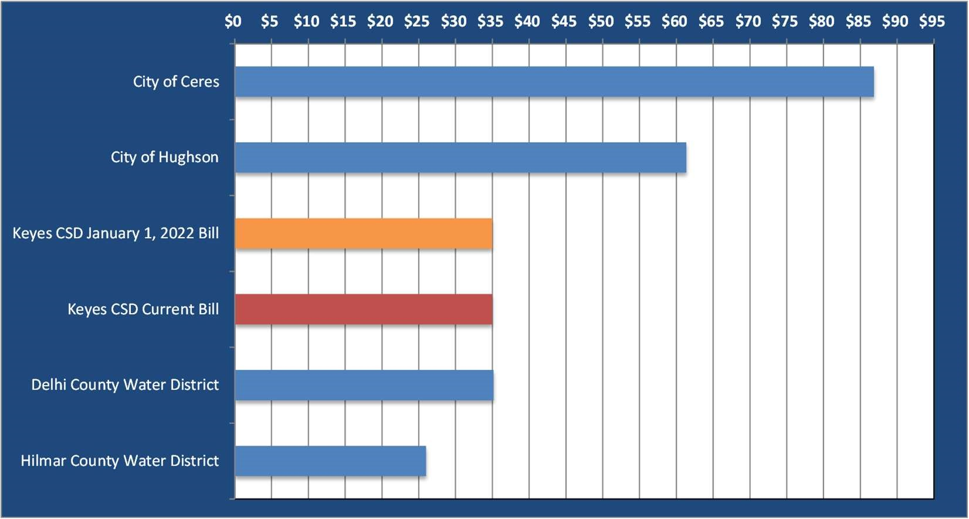
Note: Above table uses water rates in effect October 2021. Keyes CSD bill is based on the rate structure and rates in Table 12. Communities other than Keyes CSD are based on the smallest meter size listed in their rate schedule.

Wastewater Financial Planning
Financial planning for the wastewater enterprise includes identifying and projecting revenues and revenue requirements of the wastewater system for a five-year planning period. Estimates of revenue from various sources are compared with the projected revenue requirements. This comparison allows the review of the adequacy of existing revenue to meet annual obligations and provide the basis for revenue adjustments.
This section discusses the current wastewater rates, user classifications, revenues and revenue requirements, planned CIP projects and financing sources, and proposed revenue adjustments.

Current Wastewater Rates
The current wastewater rates consist of monthly fixed charges to residential and non-residential customers.
Commercial customers are further broken down into 4 categories consisting of Commercial Low, Commercial Medium, Commercial High, and Schools. The description of Low, Medium, and High refers to the strength of the wastewater in terms of bio-chemical oxygen demand (BOD) and suspended solids (SS). The current rates are presented in Table 14.
Table 14
Current Wastewater Rates
Customer | Fixed
Classification | Charge
 | ($/month)
Single-family | $64.23
Multifamily | $51.39
Commercial Low | $64.23
Commercial Medium | $111.28
Commercial High | $166.67
Schools (Elem and Middle) | $1,816.67

Wastewater User Classifications

Number of Customers
The District currently classifies wastewater customers as SFR, MFR, Commercial Low, Commercial Medium, Commercial High, and Schools classifications. Customer growth is projected to occur in SFR accounts at 0.5 percent annually or about 6 accounts per year. Residential customers account for about 97 percent of the total customers/accounts served by the wastewater system. Table 15 provides the historical and projected average number of customers by classification, MFR dwelling units, and Average Daily Attendance (ADA) for Schools.
Table 15
Historical and Projected Average Number of Wastewater Customers by Classification
 | Historical |  |  | Projected
Customer Class | FY 20-21 | FY 21-22 | FY 22-23 | FY 23-24 | FY 24-25 | FY 25-26
Number of Accounts  Single-family [1] | 1,272 | 1,278 | 1,284 | 1,290 | 1,296 | 1,302
Multifamily | 28 | 28 | 28 | 28 | 28 | 28
Commercial Low | 27 | 27 | 27 | 27 | 27 | 27
Commercial Medium | 1 | 1 | 1 | 1 | 1 | 1
Commercial High | 3 | 3 | 3 | 3 | 3 | 3
Schools (Elem and Middle) | 2 | 2 | 2 | 2 | 2 | 2
Total Accounts | 1,333 | 1,339 | 1,345 | 1,351 | 1,357 | 1,363
Number of Units  Multifamily (Dwelling Units) [1] | 390 | 392 | 394 | 396 | 398 | 400
Schools (Elem and Middle) (ADA) [2] | 796 | 796 | 796 | 796 | 796 | 796

- Residential accounts increase by 0.5% annually.
- Average Daily Attendance (ADA).

Number of Water Meters of Wastewater Customers
Table 16 provides a summary of the current and projected average number of wastewater customers by meter size. Most customers have a 3/4-inch meter (97 percent) installed at the service location. It is assumed that all new residential customers will have 1-inch meters installed and this is the minimum size for new meter installations for the District’s customer base.
Table 16
Historical and Projected Number of Water Meters by Size of Wastewater Customers
Historical  Description FY 20-21 |  |  |  | Projected
 |  | FY 21-22 | FY 22-23 | FY 23-24 | FY 24-25 | FY 25-26
Active Wastewater Meters/Accounts [1]  5/8" 28 |  | 28 | 28 | 28 | 28 | 28
3/4" | 1,290 | 1,290 | 1,290 | 1,290 | 1,290 | 1,290
1" | 1 | 7 | 13 | 19 | 25 | 31
1.5" | 0 | 0 | 0 | 0 | 0 | 0
2" | 11 | 11 | 11 | 11 | 11 | 11
3" | 0 | 0 | 0 | 0 | 0 | 0
4" Total Accounts | 3 | 3 | 3 | 3 | 3 | 3
 | 1,333 | 1,339 | 1,345 | 1,351 | 1,357 | 1,363

[1] Historical Sewer accounts for FY 20-21 were provided through City billing records.

Water Sales Volumes of Wastewater Customers
Table 17 provides the historical and projected water sales volumes of wastewater customers by classification.
Water sales volumes were projected by recognizing the growth in the number of accounts and the FY 2018-19 use per customer. Residential customers account for more than 87 percent of the water sales volumes of wastewater customers.
The water sales volumes of wastewater customers are used to calculate projected wastewater revenue and estimate wastewater discharge volumes. The wastewater discharge volumes are used for cost allocation purposes to assign cost responsibility to each class based on wastewater flow.
Table 17
Historical and Projected Water Consumption of Wastewater Customers (in HCF)
Historical  Description FY 20-21 |  |  | [1]  Projected
 | FY 21-22 | FY 22-23 | FY 23-24 | FY 24-25 | FY 25-26
Single-family 310,656 | 220,637 | 221,673 | 222,709 | 223,745 | 224,781
Multifamily 13,132 | 41,042 | 41,251 | 41,461 | 41,670 | 41,879
Commercial Low 6,275 | 5,479 | 5,479 | 5,479 | 5,479 | 5,479
Commercial Medium 47 | 41 | 41 | 41 | 41 | 41
Commercial High 15,832 | 13,824 | 13,824 | 13,824 | 13,824 | 13,824
Schools (Elem and Middle) 17,912 | 15,640 | 15,640 | 15,640 | 15,640 | 15,640
Total Projected Consumption 363,854 | 296,663 | 297,908 | 299,154 | 300,399 | 301,644

[1] Forecast assumes that the use per customer from FY 18-19 and applied to the number of customers.

Wastewater Financial Plan
The financial plan provides the means of analyzing the revenue and revenue requirements of the wastewater system and its impact on reserves as well as the ability to fund on-going O&M expense and capital infrastructure requirements. Discussed below are the projection of revenue, O&M expense, CIP needs of the wastewater system and its financing, and revenue adjustments needed to maintain a sustainable wastewater enterprise.

Revenues
The Sewer Fund receives revenue from charges for wastewater service and miscellaneous sources. Wastewater service revenue is received from rates and charges for wastewater service. Table 18 presents the projected fixed and variable rate revenue from current wastewater rates of the wastewater system. The revenue is projected by applying the current wastewater rates from Table 14 to the projected number of accounts and consumption volume. The revenue calculated is entirely fixed rate revenue.

Table 18 Projected Rate-based Wastewater Revenue Using Existing Rates
Description |  |  | Projected
 | FY 21-22 | FY 22-23 | FY 23-24 | FY 24-25 | FY 25-26
Wastewater Service Revenues  Fixed Charges ^{[1]} | $1,298,516 | $1,304,374 | $1,310,232 | $1,316,090 | $1,321,948
Variable Charges ^{[2]} | 0 | 0 | 0 | 0 | 0
Total Revenues From Current Rates | $1,298,516 | $1,304,374 | $1,310,232 | $1,316,090 | $1,321,948
- FY 21-22 and forecast revenue calculated by multiplying current water service rate by the number of projected accounts.
- There are no variable charges to w astewater customerscurrently. See Table 14.

Miscellaneous Revenue
Miscellaneous revenues are received from inspection fees. Table 19 below provides sources of wastewater miscellaneous revenue. The amount shown in the first year reflects a budgeted amount.

Table 19 Projected Wastewater Miscellaneous Revenue
Description | Budget |  | Projected
 | FY 21-22 | FY 22-23 | FY 23-24 FY 24-25 | FY 25-26

Inspection Fees $5,000 $500 $500 $500 $500

Total Miscellaneous Revenues $5,000 $500 $500 $500 $500

Revenue Requirements
Revenue requirements of the wastewater system include O&M expense and capital replacement. Each of these items are discussed below.

Operation and Maintenance Expense
O&M are an on-going obligation of the wastewater system and such costs are normally met from wastewater service revenue. O&M includes the cost to operate and maintain the wastewater collection system, lift stations, and treatment and disposal facilities. Costs also include technical services and other general and administrative expenses.
O&M has been projected recognizing the major expense categories of personnel services, electric power expense, capital outlay, and all other expenses. Personnel costs consist of salaries and benefits expense of those personnel directly involved with providing wastewater service. Salaries expense is projected to increase by 2 percent annually while benefits expense is projected to increase by 8 percent annually. Electric power expense is projected to increase annually at 3 percent while chemicals expense increases by 3 percent. All other O&M expense is projected to increase by 2 percent annually. Capital outlay is projected to increase by 3 percent annually. Table 25 provides a summary of the wastewater O&M expenses for the Study period.
Table 20
Historical and Projected Wastewater Operation and Maintenance Expense
Description | Historical | Budget |  | Projected
 | FY 20-21 | FY 21-22 | FY 22-23 | FY 23-24 | FY 24-25 | FY 25-26
Administration  Admin Salaries | $77,000 | $82,200 | $83,844 | $85,521 | $87,232 | $88,976
Benefits | 69,550 | 78,700 | 84,996 | 91,796 | 99,140 | 107,070
All Other  Subtotal | 123,680 | 100,550 | 102,561 | 104,610 | 106,702 | 118,834
 | $270,230 | $261,450 | $271,401 | $281,927 | $293,074 | $314,880
Maintenance  Maint Salaries | $118,701 | $128,000 | $130,560 | $133,171 | $135,834 | $138,551
Benefits | 103,682 | 114,000 | 123,120 | 132,970 | 143,608 | 155,096
Maintenance Contract Turlock | 8,000 | 360,000 | 367,200 | 374,544 | 382,035 | 389,676
Maintenance Utilities | 20,553 | 10,000 | 10,300 | 10,609 | 10,927 | 11,255
All Other | 406,379 | 105,050 | 107,151 | 109,295 | 111,481 | 123,710
Subtotal $657,815 $717,050 $738,331 $760,589 $783,885 $818,288

Total Wastewater System O&M Expense $928,045 $993,500 $1,025,182 $1,058,430 $1,093,350 $1,150,051

Capital Replacement
An annual amount for capital replacement is generated from the current wastewater rates and financial plan and is used towards capital spending or kept in reserve for such spending. The amount ranges from about $150,000 to $320,000 annually in the Study period.

Wastewater Capital Improvement Program
The District has developed a CIP that lists wastewater capital expenditures for FY 2021-22 through FY 2025-26, presented in Table 21. The largest project identified is the vacuum truck purchase with the maintenance shop and other asset replacement purchases shown in the table. The District projects that it will spend approximately $2.0 million over this period. The CIP is funded through wastewater rate revenue and cash reserves.
Table 21
Wastewater Capital Improvement Program
Description | Budget |  | Projected
 | FY 21-22 | FY 22-23 | FY 23-24 FY 24-25 | FY 25-26
Current Capital Improvement Program (CIP) Projects [1]  Maintenance Shop and Property Purchase | $450,000 | $0 | $0 $0 | $0
Camel Vacuum Truck Purchase | 800,000 | - | - - | -
Replace Lamp Holes with Manholes | - | - | - 109,300 | -
Proposed Asset Replacement Projects [2] | 130,000 | 130,000 | 130,000 130,000 | 130,000
Total Wastewater CIP
$1,380,000
$130,000
$130,000
$239,300
$130,000
- CIP Source: FY 21-22 District CIP document.
- Assumed annual replacement.

Wastewater Financial Plan
A financial plan has been prepared for the wastewater utility that includes the revenues and revenue requirements that were identified for the wastewater system. The plan is presented in Table 22 and incorporates specific financial planning goals to provide guidance to maintain the health of the wastewater utility on an on-going basis. The goals included the following items.

- Generate positive levels of income in each year of the Study period
- Fund capital improvement program requirements
- Maintain the operating and capital reserves at or greater than target levels
- Fund the required debt service reserve
- Maintain debt service coverage ratios at or greater than the minimum required

Proposed Revenue Adjustments
Table 22 provides the annual revenue increases recommended to meet the financial planning goals for the fiveyear Study period. The financial plan indicates that no revenue increases are required during the Study period.

Table 22 Wastewater Financial Plan
Description |  |  | Projected
 | FY 21-22 | FY 22-23 | FY 23-24 | FY 24-25 | FY 25-26
Proposed Revenue Increase (January 1) | 0.0% | 0.0% | 0.0% | 0.0% | 0.0%
Wastewater Operations
Revenue  Revenues from Existing Sewer Rates [1] | $1,298,516 | $1,304,374 | $1,310,232 | $1,316,090 | $1,321,948
Additional Revenue from Revenue Increases [2] | - | - | - | - | -
Miscellaneous Income [3] | 5,000 | 500 | 500 | 500 | 500
Interest Income [4] | 9,156 | 6,524 | 6,915 | 7,240 | 7,231

Total Revenues $1,312,672 $1,311,398 $1,317,647 $1,323,830 $1,329,679
Revenue Requirements
Operation and Maintenance Expense $993,500 $1,025,182 $1,058,430 $1,093,350 $1,150,051
Transfer to Wastewater Capital | 319,172 |  | 270,216 |  | 243,217 |  | 212,480 |  | 151,628
Total Revenue Requirements  Net Funds Available Before Capital |  | $1,312,672 |  | $1,295,398 |  | $1,301,647 |  | $1,305,830 |  | $1,301,679
 |  | $0 |  | $16,000 |  | $16,000 |  | $18,000 |  | $28,000
Wastewater Capital
Capital Sources of Funds  Transfer from Wastewater Operations  Total Capital Sources  Capital Uses of Funds |  | $319,172 |  | $270,216 |  | $243,217 |  | $212,480 |  | $151,628
 |  | $319,172 |  | $270,216 |  | $243,217 |  | $212,480 |  | $151,628
Capital Improvement Program |  | $1,380,000 |  | $130,000 |  | $130,000 |  | $239,300 |  | $130,000
Total Capital Improvement Spending |  | $1,380,000 |  | $130,000 |  | $130,000 |  | $239,300 |  | $130,000
Net Funds After Capital |  | ($1,060,828) |  | $156,216 |  | $129,217 |  | ($8,820) |  | $49,628
Available Operating and Capital Reserves
Available Reserves  Beginning available reserves [5] |  | $3,662,429 |  | $2,601,601 |  | $2,757,817 |  | $2,887,034 |  | $2,878,214
Additions (reductions) |  | (1,060,828) |  | 156,216 |  | 129,217 |  | (8,820) |  | 49,628
Ending available reserves |  | 2,601,601 |  | 2,757,817 |  | 2,887,034 |  | 2,878,214 |  | 2,927,842
Target Reserves [6] |  | 630,000 |  | 697,000 |  | 714,000 |  | 734,000 |  | 767,000
Above (below) Target |  | $1,971,601 |  | $2,060,817 |  | $2,173,034 |  | $2,144,214 |  | $2,160,842

- Projected using the existing rate schedule effective July 1, 2019.
- Additional revenue from proposed rate adjustments.
- Includes late charges, miscellaneous, and other income.
- Interest earnings on the average fund balance calculated at 0.25%.
- The available beginning FY 21-22 cash balance provided by City.
- Includes Operation and Maintenance reserve, Capital Replacement reserve, and Emergency Capital Reserve.
A graphical depiction of the revenue and revenue requirements from Table 27 are presented in Figure 3. Revenue using the current rates is shown as the red line. The figure shows that the wastewater revenue received from the current rates is sufficient to meet the needs of the wastewater utility’s annual O&M and capital requirements.
The orange column indicates that the current wastewater rates are generating cash available for capital spending and or for accumulation for such purposes in the future.
Figure 3
Wastewater Financial Plan
Comparison of Annual Revenue with Revenue Requirements

$0.0
$0.2
$0.4
$0.6
$0.8
$1.0
$1.2
$1.4
$1.6
FY 21-22
FY 23-24
FY 25-26
FY 27-28
FY 29-30
Revenues and Revenue Requirements ($ Millions)
O&M
Replacement
Debt Service
Revenue with Increases
Revenue w/o Increases
Figure 4 compares the cash reserves at the end of year with the Target Reserve level. The columns represent the cash reserve balance at the end of year while the red line indicates the Target Reserve level. The figure shows that the operating and capital fund reserve balance (column) is above the Target Reserve (red line) in all years and is adequate to meet Target Reserve levels.
Figure 4
Wastewater Cash Reserves
Comparison of Projected End of Year Cash Reserves with Target Reserve Level

$0.0
$0.5
$1.0
$1.5
$2.0
FY 21-22
FY 23-24
FY 25-26
FY 27-28
FY 29-30
(
)
$ Millions
Total Reserves
Target Reserves

Wastewater Rate Design
The goal of the rate design is to achieve fairness while ensuring that each customer class pays its fair share of costs. Rates should be simple to administer, easy to understand, and comply with regulatory requirements. The current District wastewater rates account for customer flow and strength and meet industry accepted methodology for wastewater rates.
From Table 22, no revenue increases were required to maintain a sustainable wastewater enterprise and no change to the District’s wastewater rate structure is recommended at this time.

Proposed Wastewater Rates
Table 23 presents the proposed fixed charges for the wastewater system for the next five years. The current fixed charges are provided in the table as well as the proposed charges.
Table 23
Current and Proposed Wastewater Fixed Charges
Current | January 1, January 1, January 1, January 1, January 1,
Rate | 2022 2023 2024 2025 2026
Fixed Charge ($ per month)

Single-family | $64.23 | $64.23 | $64.23 | $64.23 | $64.23 | $64.23
Multifamily | $51.39 | $51.39 | $51.39 | $51.39 | $51.39 | $51.39
Commercial Low | $64.23 | $64.23 | $64.23 | $64.23 | $64.23 | $64.23
Commercial Medium | $111.28 | $111.28 | $111.28 | $111.28 | $111.28 | $111.28
Commercial High | $166.67 | $166.67 | $166.67 | $166.67 | $166.67 | $166.67
Schools (Elem and Middle) | $1,816.67 | $1,816.67 | $1,816.67 | $1,816.67 | $1,816.67 | $1,816.67

Wastewater Bill Impact Analysis
There is no impact to SFR customer wastewater bills since the proposed wastewater rates are the same as the current rates. As shown in Table 24, a SFR customer experiences no change in their monthly bill. Wastewater bills for other classifications are also provided in the table.
Table 24
Comparison of Current Monthly Wastewater Bills with Bills Using
Proposed Wastewater Rates
 |  | Proposed January 1, 2022 Bill
Customer Class |  | Current Monthly Bill |  | Proposed Monthly Bill |  | Dollar Difference |  | Percent  Increase
 | Single-family |  | $64.23 |  | $64.23 |  | $0.00 |  | 0.0%
 | Multifamily |  | $51.39 |  | $51.39 |  | $0.00 |  | 0.0%
 | Commercial Low |  | $64.23 |  | $64.23 |  | $0.00 |  | 0.0%
 | Commercial Medium |  | $111.28 |  | $111.28 |  | $0.00 |  | 0.0%
 | Commercial High |  | $166.67 |  | $166.67 |  | $0.00 |  | 0.0%
 | Schools (Elem and Middle) |  | $1,816.67 |  | $1,816.67 |  | $0.00 |  | 0.0%

Wastewater Rate Survey
A wastewater rate survey was conducted for neighboring communities to the Keyes Community Services District. Chart 2 compares the District’s SFR monthly wastewater bill with those of neighboring communities. The rate survey includes rate schedules in effect October 2021. Wastewater bills for the District are shown using the current rates and the proposed rates. The chart indicates that a District SFR customer will experience a bill that is in the mid to upper range of the communities listed.
Chart 2
Comparison of Single-family Residential Monthly Wastewater Bills
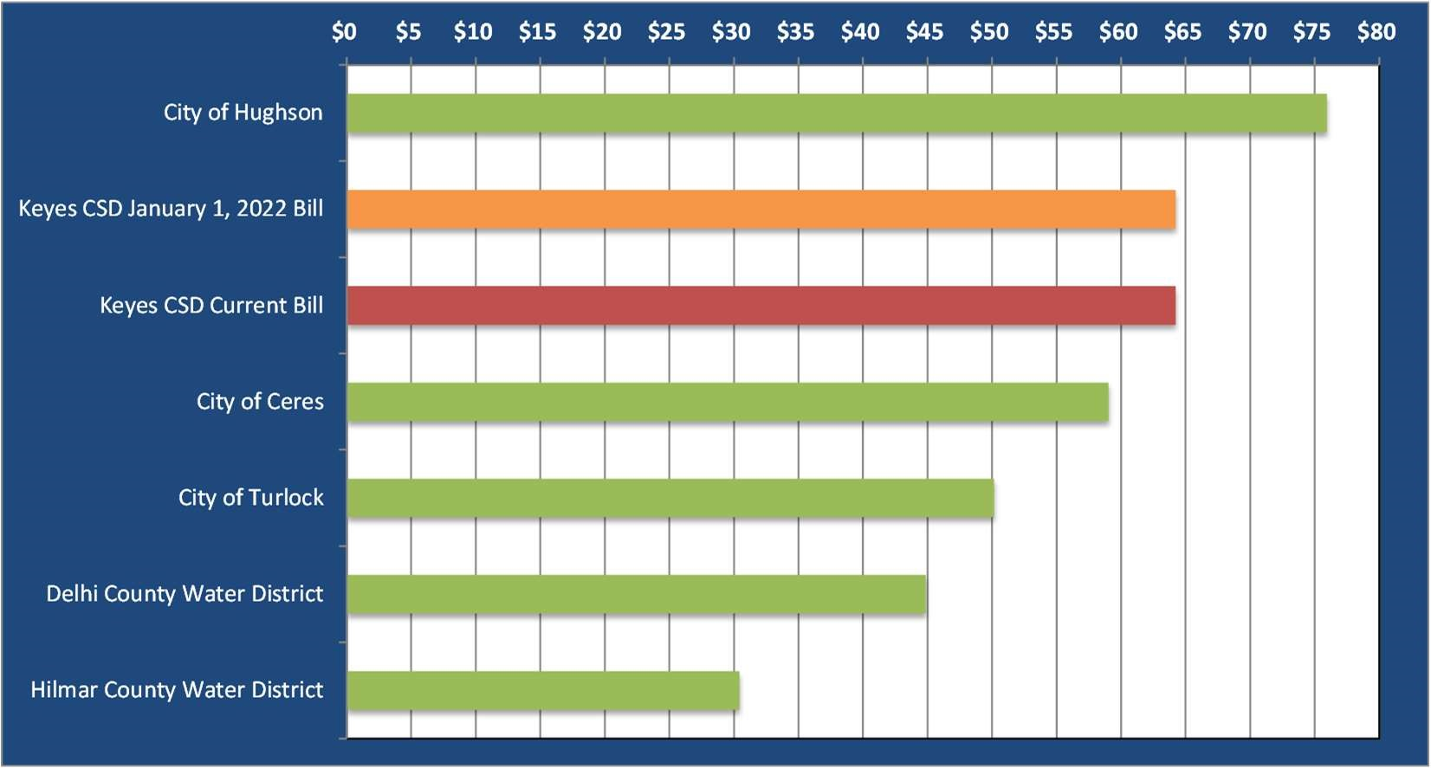
Note: Above table uses wastewater rates in effect October 2021. Keyes Community Services District bill is based on the rate structure and rates in Table 23.

