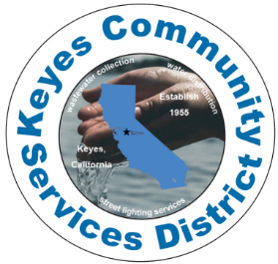

PUBLIC NOTICE

KEYES COMMUNITY SERVICES DISTRICT
NOTICE OF PUBLIC HEARING
PROPOSED BUDGET FOR FISCAL YEAR 2023/2024
NOTICE IS HEREBY GIVEN that the Governing Board of Keyes Community Services District will hold a public hearing for the Proposed Budget for Fiscal Year 2023/2024.
Date: May 23, 2023 Time: 6:00 p.m.
Location: 5601 7th Street, Keyes, Ca. 95328
Copies of the Proposed Budget for 2023/2024 are on file and may be inspected at the Keyes CSD Office at 5601 7th Street, Keyes, Ca 95328. Copies may be ordered by written request and a check for $3.50 made payable to Keyes CSD at 5601 7th Street, Keyes, Ca 95328.
Contact Michelle Harris at 209-668-8341, extension 102 for further information.

