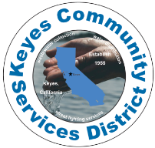

Keyes Community Services District

5601 7th Street, P O Box 699

Keyes, Ca 95328

209-668-8341

209-668-8396

August 6, 2024

Greetings to all:

This letter is to inform and update you on the progress of our TCP (trichloropropane) project. This is a project that will improve the quality and safety of our drinking water.

The construction of our water filtration project that will eliminate the threat of the chemical 1,2,3-TCP will begin this month of August. The installation of these water filters will take place on the empty lot that is north of the community center (PAL building). The contractor will also install water filters at Well #9 located at Faith Home Road north of Keyes Road. Once this project is complete, we will have the safest drinking water ever. Our engineers held a pre-construction meeting with the contractor last month and the tentative project starting date is August 26, 2024.

The total project cost is estimated at $15 million with $12 million of this amount being paid by the Environmental Protection Agency. Our district’s share of the cost is about $3 million. KCSD has a very healthy fund account to pay for our share therefore, there is no need to worry about raising water service rates for a long time to come.

If you have any questions or concerns regarding this project, please feel free to contact me or our maintenance staff

Regards,

Ernie Garza

KCSD General Manager

Office: 209-668-8341